General Conical Surface
# Source: AI Source: Provided by: [Data Path: Persons Table -> ID Column: 1, Name_En Column: Motasem Essam] -> From: [ChatGPT] on [7/20/2026]
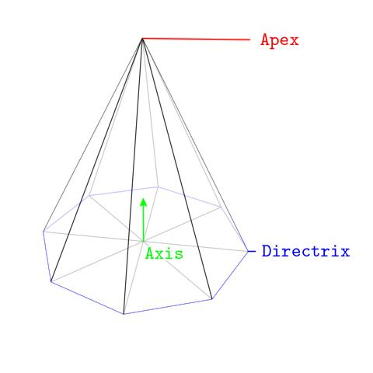
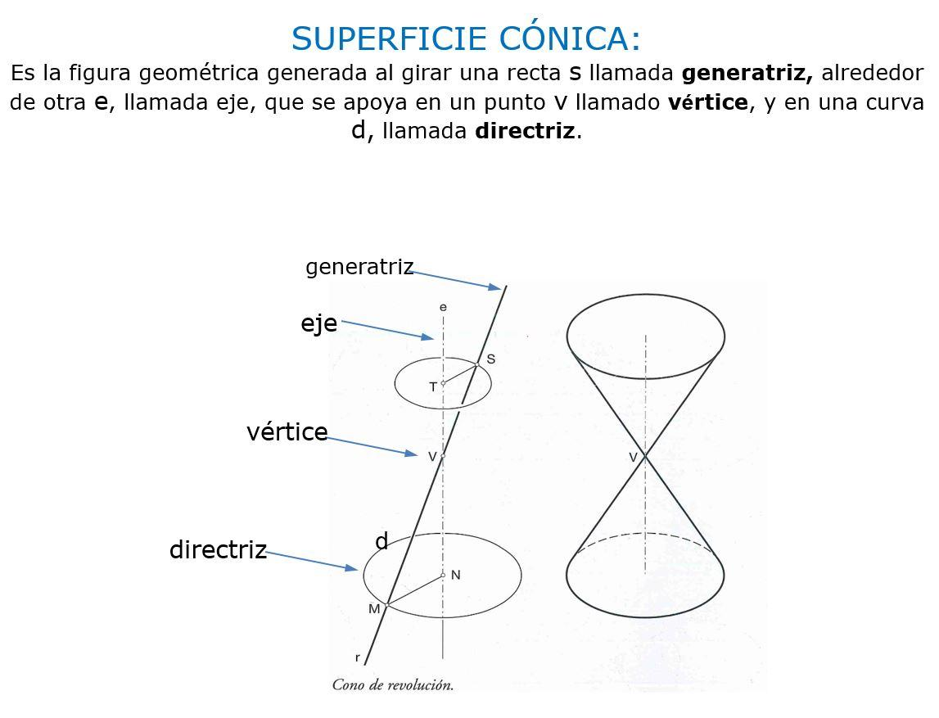
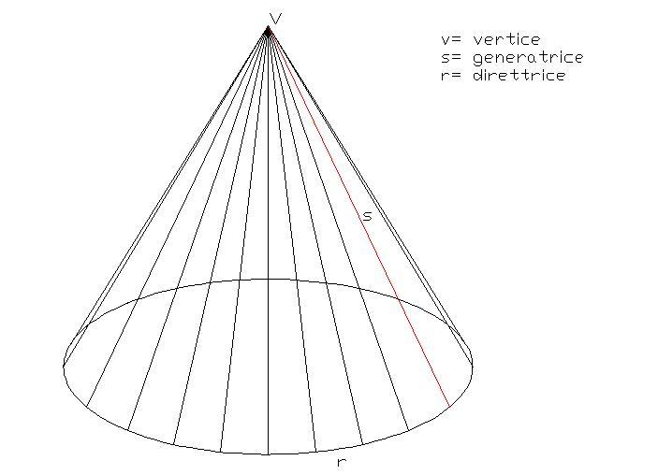
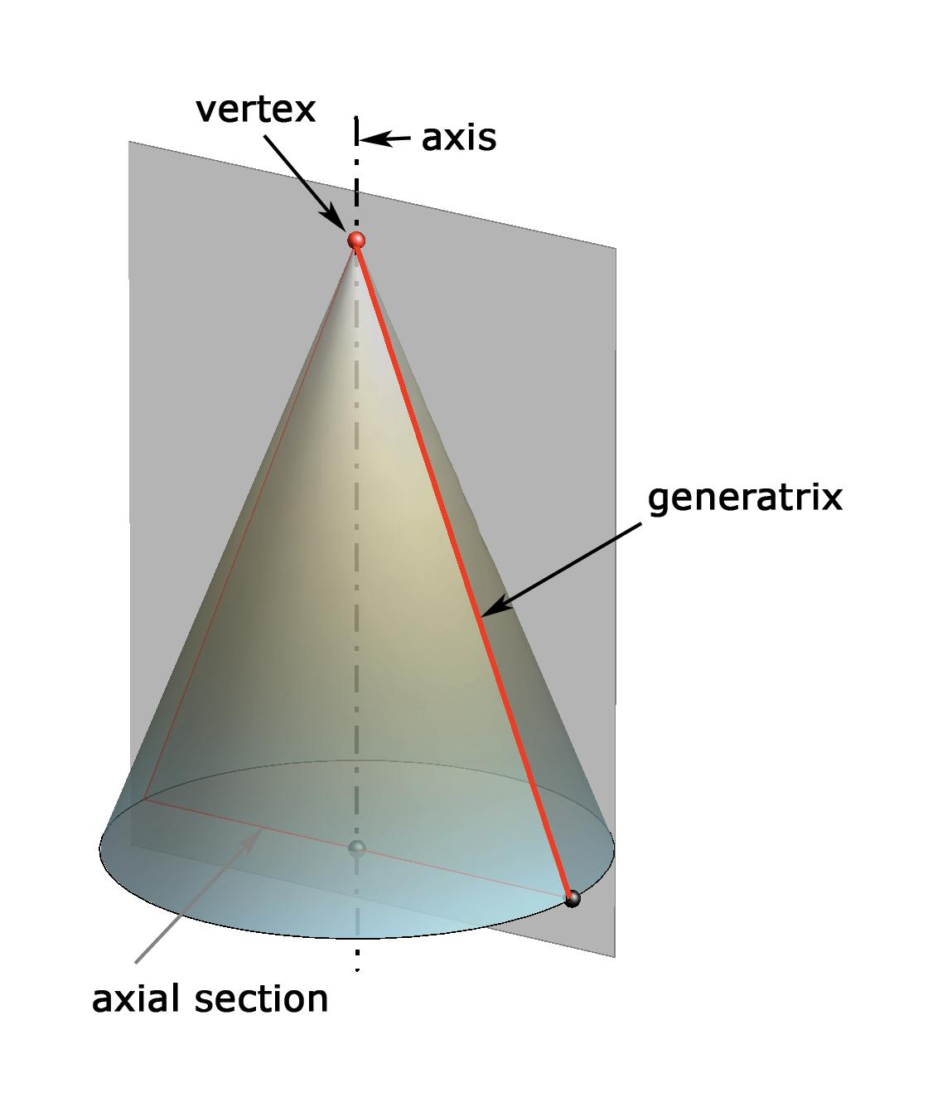

Definition
# Source: AI Source: Provided by: [Data Path: Persons Table -> ID Column: 1, Name_En Column: Motasem Essam] -> From: [ChatGPT] on [7/20/2026]
A General Conical Surface is a surface generated by a straight line, called a generator, that passes through a fixed point called the vertex and moves along a fixed curve called the directrix.
The directrix can be a curve of many different shapes and does not necessarily have to be a circle.
The defining property is:
$$\boxed{\text{All generators pass through one fixed vertex}}$$
Thus, a general conical surface is the broader class that includes circular conical surfaces and other conical surfaces.

Purpose
# Source: AI Source: Provided by: [Data Path: Persons Table -> ID Column: 1, Name_En Column: Motasem Essam] -> From: [ChatGPT] on [7/20/2026]
A general conical surface is used to:
- Describe conical surfaces with arbitrary directrices.
- Generalize right and oblique circular conical surfaces.
- Study surfaces generated by lines passing through a common point.
- Model non-circular conical structures.
- Provide a foundation for advanced surface geometry.
- Describe surfaces in analytic geometry, calculus, CAD, and engineering.

Fundamental Elements
# Source: AI Source: Provided by: [Data Path: Persons Table -> ID Column: 1, Name_En Column: Motasem Essam] -> From: [ChatGPT] on [7/20/2026]
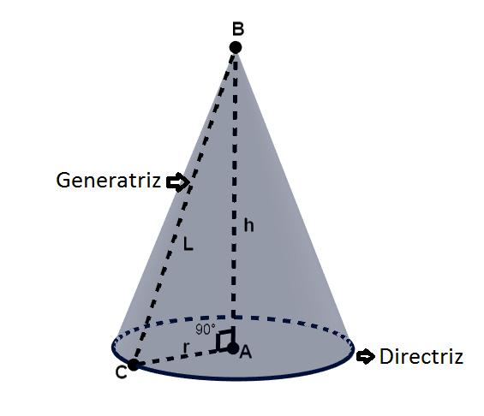

1. Vertex
# Source: AI Source: Provided by: [Data Path: Persons Table -> ID Column: 1, Name_En Column: Motasem Essam] -> From: [ChatGPT] on [7/20/2026]
The vertex $V$is the fixed point through which all generators pass.
It is the defining fixed point of the conical surface.

2. Directrix
# Source: AI Source: Provided by: [Data Path: Persons Table -> ID Column: 1, Name_En Column: Motasem Essam] -> From: [ChatGPT] on [7/20/2026]
The directrix is the fixed curve that determines the shape of the surface.
It may be:
- A circle
- An ellipse
- A parabola
- A hyperbola
- Another suitable plane curve
- In more general settings, a spatial curve

3. Generator
# Source: AI Source: Provided by: [Data Path: Persons Table -> ID Column: 1, Name_En Column: Motasem Essam] -> From: [ChatGPT] on [7/20/2026]
A generator is a straight line passing through the vertex and a point on the directrix.
If $P$is a point on the directrix, then the line
$$VP$$
is a generator.
As $P$moves along the directrix, the generator sweeps out the conical surface.

4. Axis
# Source: AI Source: Provided by: [Data Path: Persons Table -> ID Column: 1, Name_En Column: Motasem Essam] -> From: [ChatGPT] on [7/20/2026]
A conventional axis is not necessarily defined for a general conical surface.
An axis is naturally available for highly symmetric cases such as the right circular cone.

5. Height
# Source: AI Source: Provided by: [Data Path: Persons Table -> ID Column: 1, Name_En Column: Motasem Essam] -> From: [ChatGPT] on [7/20/2026]
A unique elementary height is not necessarily defined for every general conical surface.
Height becomes particularly meaningful when the directrix lies in a plane and a perpendicular distance from the vertex to that plane is considered.

General Geometric Construction
# Source: AI Source: Provided by: [Data Path: Persons Table -> ID Column: 1, Name_En Column: Motasem Essam] -> From: [ChatGPT] on [7/20/2026]
The construction can be summarized as:
$$\boxed{\text{Directrix}+\text{Common Vertex}+\text{Generators}→\text{Conical Surface}}$$
Suppose $C$is a directrix and $V$is a fixed point not on $C$.
For every point
$$P∈C,$$
draw the line through $V$and $P$.
The collection of these lines forms the conical surface.
Conceptually:
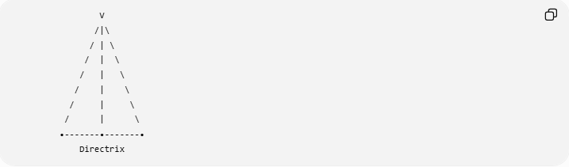
V
/|\
/ | \
/ | \
/ | \
/ | \
/ | \
/ | \
•-------•-------•
Directrix

Mathematical Representation
# Source: AI Source: Provided by: [Data Path: Persons Table -> ID Column: 1, Name_En Column: Motasem Essam] -> From: [ChatGPT] on [7/20/2026]
Let the directrix be parameterized by
$$c\left(u\right)$$
and let the fixed vertex be
$$V.$$
A generator connecting $V$to the point $c\left(u\right)$can be represented by
$$r\left(u , t\right)=V+t\left(c\left(u\right)-V\right).$$
Therefore,
$$\boxed{r\left(u , t\right)=\left(1-t\right)V+tc\left(u\right)}$$
where $t$determines the position along each generator.
For a finite lateral surface between the vertex and the directrix,
$$0≤t≤1.$$
At
$$t=0,$$
we obtain the vertex:
$$r\left(u , 0\right)=V.$$
At
$$t=1,$$
we reach the directrix:
$$r\left(u , 1\right)=c\left(u\right).$$

Example – Elliptical Conical Surface
# Source: AI Source: Provided by: [Data Path: Persons Table -> ID Column: 1, Name_En Column: Motasem Essam] -> From: [ChatGPT] on [7/20/2026]
Suppose the directrix is an ellipse:
$$\frac{x^{2}}{9}+\frac{y^{2}}{4}=1$$
in the plane
$$z=0.$$
Let the vertex be
$$V=\left(0 , 0 , 6\right).$$
Every point of the ellipse is connected to $V$by a straight line.
The resulting surface is an:
$$\boxed{\text{Elliptical Conical Surface}}$$
It is a general conical surface because its directrix is not a circle.

Example – Parabolic Conical Surface
# Source: AI Source: Provided by: [Data Path: Persons Table -> ID Column: 1, Name_En Column: Motasem Essam] -> From: [ChatGPT] on [7/20/2026]
Suppose the directrix is the parabola
$$y=x^{2}$$
in a plane, and a fixed vertex is located away from the parabola.
Connecting every point of the parabola to the vertex produces a:
$$\boxed{\text{Parabolic Conical Surface}}.$$
This demonstrates that a conical surface does not require a circular base.

Types of General Conical Surfaces
# Source: AI Source: Provided by: [Data Path: Persons Table -> ID Column: 1, Name_En Column: Motasem Essam] -> From: [ChatGPT] on [7/20/2026]
The directrix provides one useful classification:

Directrix | Conical Surface
Circle | Circular conical surface
Ellipse | Elliptical conical surface
Parabola | Parabolic conical surface
Hyperbola | Hyperbolic conical surface
Other curve | General conical surface
Thus:
$$\boxed{\text{Circular Conical Surface}⊂\text{General Conical Surface}}$$
when General Conical Surface is being used as the broad category.

Circular Conical Surface as a Special Case
# Source: AI Source: Provided by: [Data Path: Persons Table -> ID Column: 1, Name_En Column: Motasem Essam] -> From: [ChatGPT] on [7/20/2026]
A circular conical surface is obtained when the directrix is a circle.
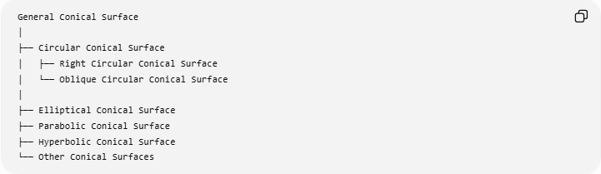
General Conical Surface
│
├── Circular Conical Surface
│ ├── Right Circular Conical Surface
│ └── Oblique Circular Conical Surface
│
├── Elliptical Conical Surface
├── Parabolic Conical Surface
├── Hyperbolic Conical Surface
└── Other Conical Surfaces
Therefore, the previous topics fit naturally into this hierarchy.

Right and Oblique Classification
# Source: AI Source: Provided by: [Data Path: Persons Table -> ID Column: 1, Name_En Column: Motasem Essam] -> From: [ChatGPT] on [7/20/2026]
The terms right and oblique describe the orientation of a conical surface relative to its directrix plane.
For a circular directrix:
Right Circular Conical Surface
The axis is perpendicular to the base plane:
$$\boxed{\text{axis}⊥\text{base plane}}$$
Oblique Circular Conical Surface
The axis is not perpendicular to the base plane:
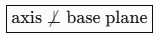
$$\boxed{\text{axis}⊥̸\text{base plane}}$$
These are therefore special cases of circular conical surfaces, rather than separate fundamental categories of all general conical surfaces.

General Surface Area
# Source: AI Source: Provided by: [Data Path: Persons Table -> ID Column: 1, Name_En Column: Motasem Essam] -> From: [ChatGPT] on [7/20/2026]
There is no single elementary surface-area formula for every general conical surface.
For a general parametric representation
$$r\left(u , t\right)=V+t\left(c\left(u\right)-V\right),$$
the surface area is calculated using
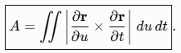
$$\boxed{A=\int{∫}∣\frac{∂r}{∂u}×\frac{∂r}{∂t}∣ du dt}.$$
The result depends on:
- The shape of the directrix.
- The location of the vertex.
- The size of the directrix.
- The geometry of the generators.
- The portion of the surface being considered.
Therefore, formulas such as
$$A=πrl$$
should not be applied to a general conical surface.
That formula belongs specifically to the appropriate right circular cone.

Surface Area of a Right Circular Cone
# Source: AI Source: Provided by: [Data Path: Persons Table -> ID Column: 1, Name_En Column: Motasem Essam] -> From: [ChatGPT] on [7/20/2026]
As a special case, if the directrix is a circle and the cone is right circular,
$$\boxed{A=πrl}.$$
The slant height satisfies
$$\boxed{l^{2}=r^{2}+h^{2}}.$$
This simple formula is a consequence of the symmetry of the right circular cone and is not a general property of all conical surfaces.

Volume
# Source: AI Source: Provided by: [Data Path: Persons Table -> ID Column: 1, Name_En Column: Motasem Essam] -> From: [ChatGPT] on [7/20/2026]
For a conical solid whose base is a plane region of area $B$and whose vertex has perpendicular height $h$from the base plane, the volume is
$$\boxed{V=\frac{1}{3}Bh}.$$
For a circular base,
$$B=πr^{2},$$
so
$$\boxed{V=\frac{1}{3}πr^{2}h}.$$
This applies to both right and oblique circular cones when $h$is the perpendicular height.
For a completely arbitrary directrix, however, a simple elementary volume formula requires additional information about the enclosed base region.

Main Properties
# Source: AI Source: Provided by: [Data Path: Persons Table -> ID Column: 1, Name_En Column: Motasem Essam] -> From: [ChatGPT] on [7/20/2026]
A general conical surface has the following properties:
- It has a fixed vertex.
- Every generator passes through that vertex.
- The generators are generally not parallel.
- A fixed directrix determines the surface.
- The directrix does not have to be circular.
- The surface is generally curved.
- The surface has a common apex or vertex.
- A conventional axis may not exist.
- A single slant height may not exist.
- A simple radius may not exist.
- The finite lateral surface generally has a boundary corresponding to the directrix.
- Adding a suitable base region can produce a closed solid.
- Surface area generally requires more information than the right circular case.

General Conical Surface vs General Cylindrical Surface
# Source: AI Source: Provided by: [Data Path: Persons Table -> ID Column: 1, Name_En Column: Motasem Essam] -> From: [ChatGPT] on [7/20/2026]
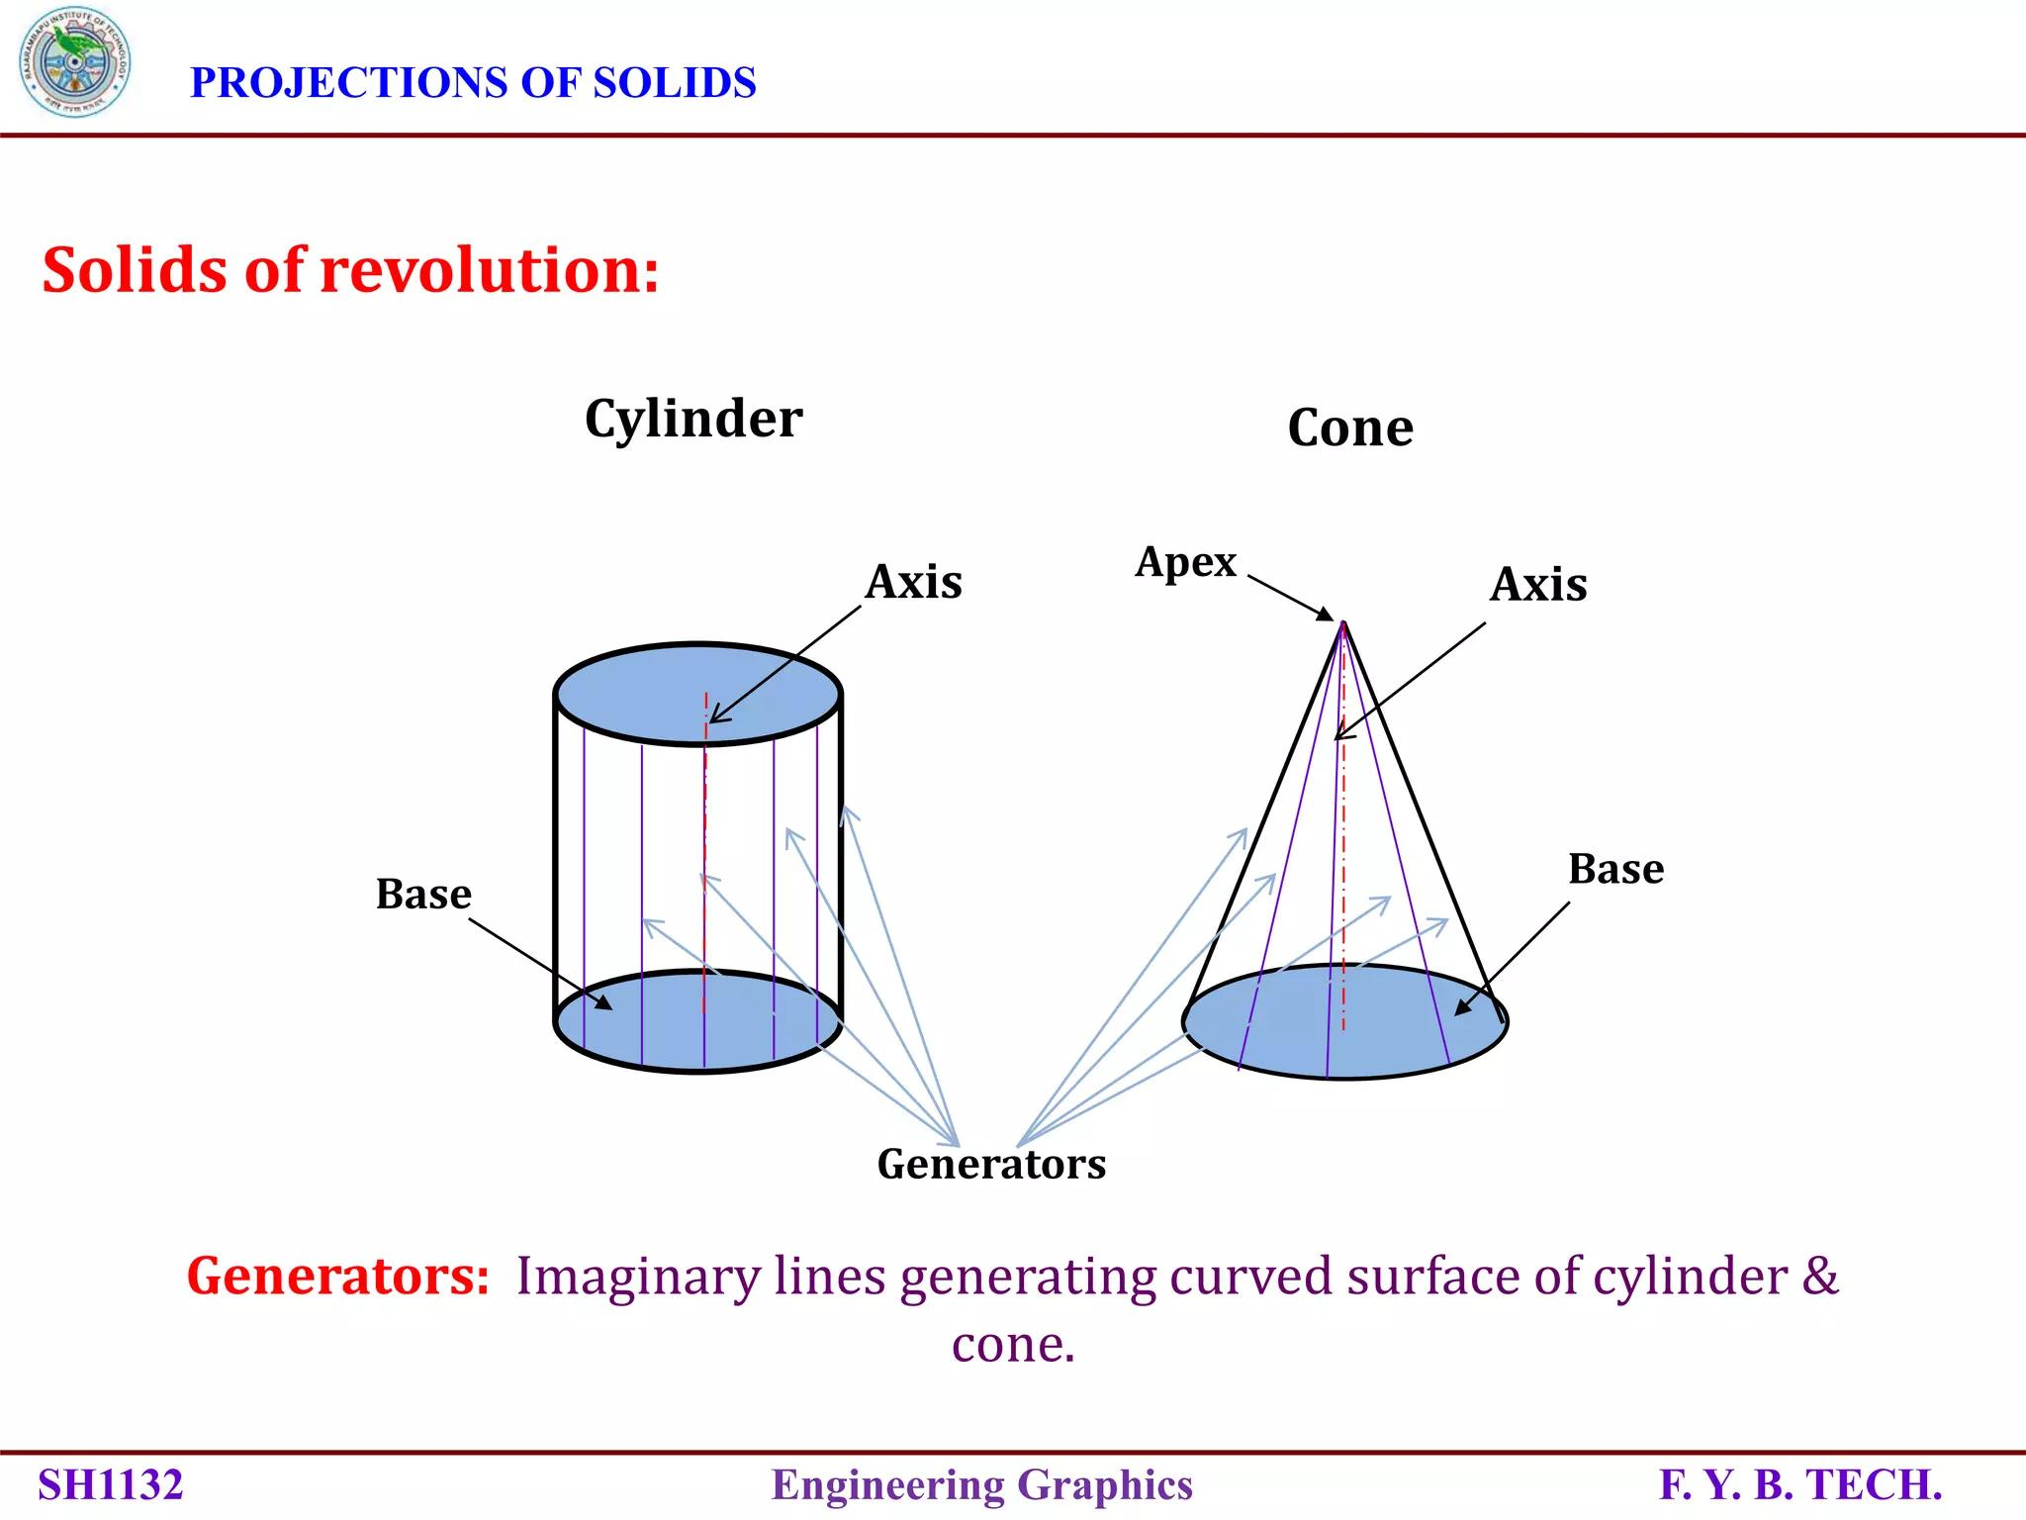
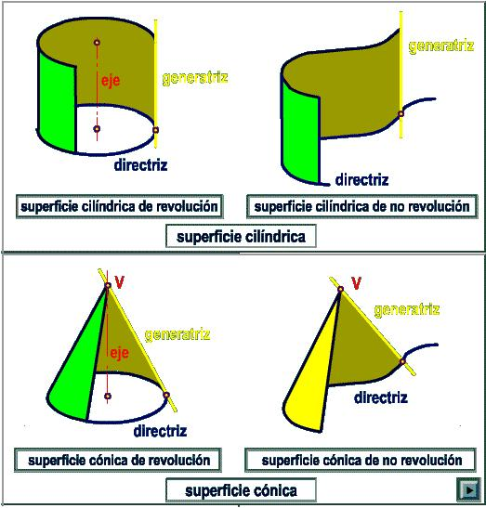
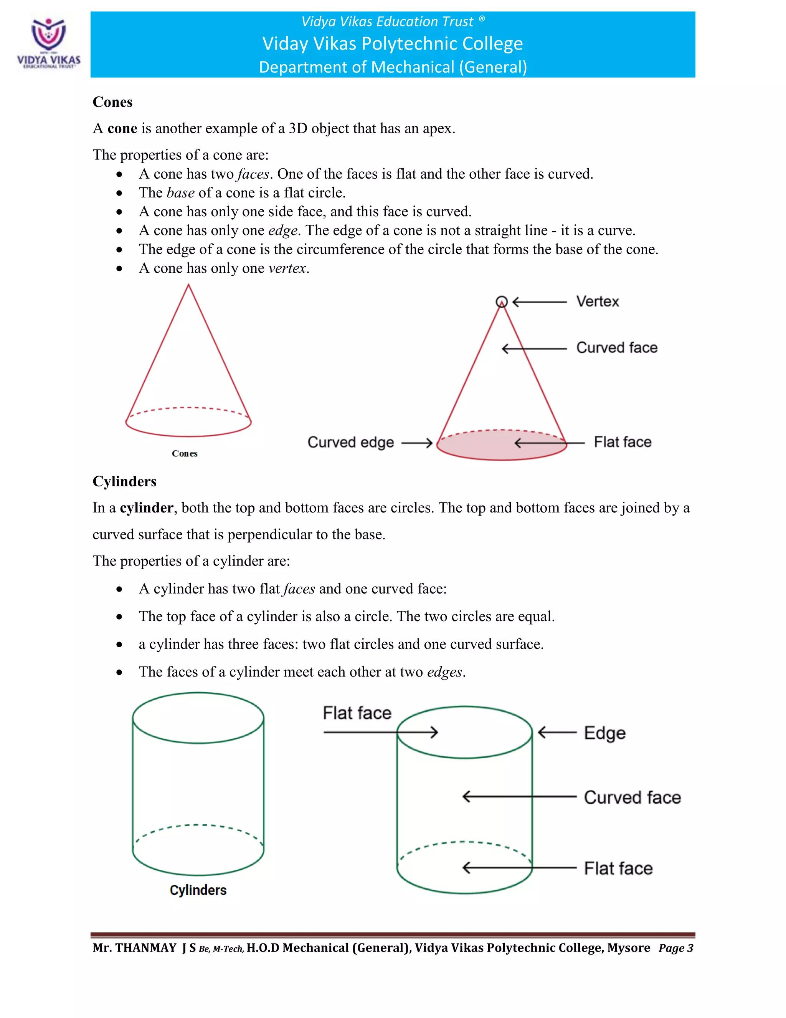
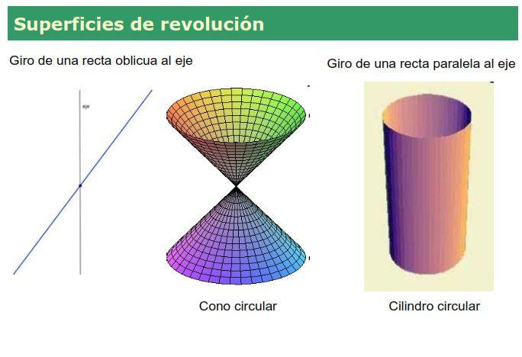
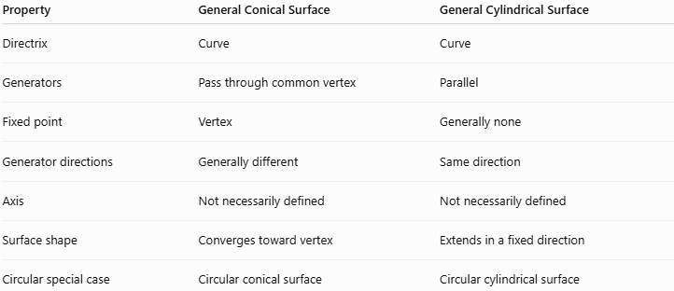
Property | General Conical Surface | General Cylindrical Surface
Directrix | Curve | Curve
Generators | Pass through common vertex | Parallel
Fixed point | Vertex | Generally none
Generator directions | Generally different | Same direction
Axis | Not necessarily defined | Not necessarily defined
Surface shape | Converges toward vertex | Extends in a fixed direction
Circular special case | Circular conical surface | Circular cylindrical surface
The fundamental distinction is:
$$\boxed{\text{Conical surface: generators meet at a vertex}}$$
while
$$\boxed{\text{Cylindrical surface: generators are parallel}}.$$

General Conical Surface vs General Cylindrical Surface
# Source: AI Source: Provided by: [Data Path: Persons Table -> ID Column: 1, Name_En Column: Motasem Essam] -> From: [ChatGPT] on [7/20/2026]
A useful geometric interpretation is:
Conical
$$\boxed{\text{One fixed point}+\text{directrix}→\text{generators through the point}}$$
Cylindrical
$$\boxed{\text{One fixed direction}+\text{directrix}→\text{parallel generators}}$$
This distinction is fundamental to the classification of ruled surfaces.

Open and Closed Surface
# Source: AI Source: Provided by: [Data Path: Persons Table -> ID Column: 1, Name_En Column: Motasem Essam] -> From: [ChatGPT] on [7/20/2026]
A finite general conical lateral surface is normally open, because the directrix forms its boundary.
For example:
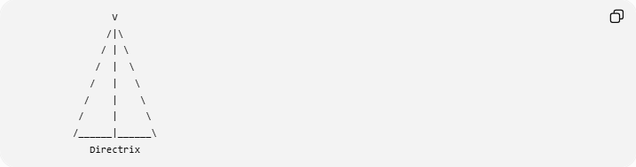
V
/|\
/ | \
/ | \
/ | \
/ | \
/ | \
/______|______\
Directrix
The surface itself does not include the interior base region.
If the base region enclosed by the directrix is added, the resulting boundary can become a closed surface.
Therefore:
$$\boxed{\text{Conical lateral surface}=\text{open}}$$
while
$$\boxed{\text{Conical lateral surface + base}=\text{closed}}$$
for the usual finite cone construction.

Real-World Applications
# Source: AI Source: Provided by: [Data Path: Persons Table -> ID Column: 1, Name_En Column: Motasem Essam] -> From: [ChatGPT] on [7/20/2026]
General conical surfaces are used in:
- Engineering design
- Architectural structures
- CAD modeling
- Mechanical components
- Funnels and hoppers
- Nozzles
- Reflectors
- Structural supports
- Fluid-flow equipment
- Computer graphics
- Surface modeling
Non-circular conical surfaces can be particularly useful when a structure needs an elliptical, parabolic, or other specialized cross-section.

Advantages
# Source: AI Source: Provided by: [Data Path: Persons Table -> ID Column: 1, Name_En Column: Motasem Essam] -> From: [ChatGPT] on [7/20/2026]
- Provides a general framework for conical geometry.
- Includes circular conical surfaces as special cases.
- Can represent many different directrix shapes.
- Useful for mathematical modeling.
- Provides a natural parametric representation.
- Important in calculus, CAD, engineering, and computer graphics.

Limitations
# Source: AI Source: Provided by: [Data Path: Persons Table -> ID Column: 1, Name_En Column: Motasem Essam] -> From: [ChatGPT] on [7/20/2026]
- No universal simple surface-area formula.
- A radius may not exist.
- A single slant height may not exist.
- A conventional axis may not exist.
- The geometry becomes more complicated for irregular directrices.
- Advanced cases may require parametric equations and calculus.

Relationship with Other Conical Surfaces
# Source: AI Source: Provided by: [Data Path: Persons Table -> ID Column: 1, Name_En Column: Motasem Essam] -> From: [ChatGPT] on [7/20/2026]
The hierarchy can be summarized as:
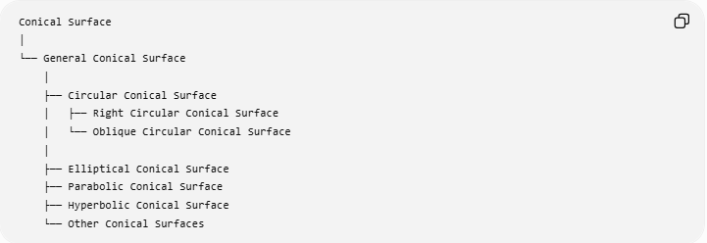
Conical Surface
│
└── General Conical Surface
│
├── Circular Conical Surface
│ ├── Right Circular Conical Surface
│ └── Oblique Circular Conical Surface
│
├── Elliptical Conical Surface
├── Parabolic Conical Surface
├── Hyperbolic Conical Surface
└── Other Conical Surfaces
However, for a strict mathematical taxonomy, there is an important terminology point: the phrase general conical surface is often used as the broad definition of a surface generated by lines through a fixed vertex, rather than as one specific sibling alongside circular conical surfaces. So the hierarchy above is primarily a knowledge-base organizational structure.

Key Points
# Source: AI Source: Provided by: [Data Path: Persons Table -> ID Column: 1, Name_En Column: Motasem Essam] -> From: [ChatGPT] on [7/20/2026]
- A General Conical Surface is generated by straight lines passing through one fixed vertex.
- The generators meet at the vertex rather than remaining parallel.
- A directrix determines the shape of the surface.
- The directrix does not have to be a circle.
- Circular, elliptical, parabolic, and other directrices can produce conical surfaces.
- The general parametric form is
$$\boxed{r\left(u , t\right)=\left(1-t\right)V+tc\left(u\right)}$$
- A general conical surface does not necessarily have a conventional axis, radius, or single slant height.
- The simple formula
$$A=πrl$$
is specific to the right circular case and should not be generalized.
- For a circular conical solid, the volume is
$$\boxed{V=\frac{1}{3}πr^{2}h}.$$
- The essential distinction from a cylindrical surface is:
$$\boxed{\text{Conical: generators meet at a vertex}} \\ \boxed{\text{Cylindrical: generators are parallel}}$$

Conclusion
# Source: AI Source: Provided by: [Data Path: Persons Table -> ID Column: 1, Name_En Column: Motasem Essam] -> From: [ChatGPT] on [7/20/2026]
A General Conical Surface is the broad geometric concept of a surface formed by straight generators that all pass through a single fixed vertex while intersecting a directrix. The directrix may have many different shapes, making the general conical surface much broader than the familiar circular cone.
For your knowledge base, the most useful conceptual classification is:
$$\boxed{\text{Conical Surface}→\left\{\begin{matrix}\text{Circular Conical Surface} \\ \text{Elliptical Conical Surface} \\ \text{Parabolic Conical Surface} \\ \text{Hyperbolic Conical Surface} \\ \text{Other Conical Surfaces}\end{matrix}\right.}$$
with Right/Oblique treated as a separate orientation classification where applicable.

